**Materials Science and Engineering**

**Introduction and basic principles**

Everything around us is made up of materials, and they are basic substances that have mass and occupy space. The air we breathe, the water we drink and the food we eat and so on. They can be natural or human-made. Natural materials are materials that come from animals, plants and rocks and manufactured materials are those obtained from natural materials through chemical processes. A wide range of materials in nature form an essential part of the ecosystem in multiple ways. The materials that are used not only in the field of engineering, but on a day to day basis because of their properties are called engineering materials. Material engineers develop and test new materials for different specific applications. A wide range of new products like computer chips, recreational equipment (golf clubs, bicycles), and building materials for houses, bridges, cars, and aircraft will be created. Advanced materials refer to all new materials and modifications to existing materials to obtain superior performance in one or more functional features that are critical for the application under consideration. The functional materials perform specific functions within a system. Some recent advances include shape memory alloys and nanomaterials. Supermaterials of the future include aerogel, carbon nanotube, transparent alumina, e-textiles, metamaterials, nano-diamond and amorphous metal. Graphene is the thinnest material ever invented-only one atom thick yet stronger than steel. Every material has a set of physical and chemical properties that define it. The physical properties include melting point, boiling point, color, hardness, density and so forth. The chemical properties include reactivity with water, oxygen, acids, bases, and others. Traditionally, materials were developed keeping in mind a particular set of properties and were mainly used for making components and structures. With the advancement of materials science, they are expected to perform the role of an ‘intelligent’ structure. An excellent example of this would be applications of shape memory alloys, and they can be used to make deployable antennas. These materials enable people to explore the design and use of new products to improve the quality of life. Modern materials are employed in the primary production or manufacturing of a good, and there are about 3,00,000 different known materials. These include specialty and bulkchemicals, beverages and food products, metal products and alloys, wood and paper products, rubber and plastic products, textile and consumer goods, and those used in mining and metallurgy, and printing and publishing industries.

The kind of questions that a student in materials science would like answers to include the following; What is the densest crystal packing that can be achieved? How do intermolecular attractions arise? Why is glass transparent and brittle while copper opaque and ductile? Why is a diamond an efficient thermal conductor, but electrical insulator? Why is it easier to bend the Al rod as compared to the steel rod? Why is a wire of copper conducting, while a piece of dry wood non-conducting? How can we change properties like hardness, flexibility, biocompatibility in a material? Why does the electrical conductivity of Ag decrease on heating, while that of Si increases? Why does naphthalene (para-dichlorobenzene) solid evaporate? How can we explain the fact that good thermal conductors are also good electrical conductors? How can one understand the observations that when we release the load on a rubber band/spring, it comes back to its original shape while a bent aluminum rod would not come back? Why is it essential for some objects being transparent? Why is glass transparent to visible light, but opaque to UV light? Why can aluminum oxide exist as a transparent, translucent or opaque a material? What are the reasons for the viscosity of honey, mercury and paraffin oil? Why are composites used instead of metals, ceramics, or polymers? What is the mechanism behind functional smart materials? What does material science offer to society? Who can deny the role of materials in human existence? The answers to such questions could lead the learner to take the subject to higher levels of understanding, an understanding of the complex structure-property relationships, molecular mechanisms of material transformations, the development of an active system, to arrive at practical science-based solutions, and finally better materials management solutions.

Materials technology includes a range of materials used for manufacturing products, machines, and structures. For example, plastics are used in solid form as synthetic fibers for textiles, a film for packaging and in composites like fiberglass. Metals like iron or aluminum continue to be essential for building machines and structures. Concrete is the prime material for building civil structures such as bridges. Some building materials like steel, concrete, and bricks are structural while others, such as ceramics and glass are mainly decorative. Appropriate technology serves local needs using local resources such as stone and wood. Rubber is used for the soles of shoes and motor tires because of its resilience and elasticity. It is also used in rubber gloves and rainwear due to its flexibility and waterproof property. Plaster of Paris (POP) has the distinct feature of setting into a hard mass on wetting with water. It is used to make castings for statues, toys and decorative materials, for setting broken or fractured bones in the right position and as a fireproofing material. Thin-film materials are used extensively in sensor applications. Thin film solar cells like amorphous silicon, cadmium telluride, copper indium gallium selenide and dye-sensitized solar cells are other examples of important novel materials. The nano-scale effects on sterical and biological properties include increased selectivity for specific drug transportation and controlled release, increased permeability through membranes, and improved biocompatibility. The role of materials science research, technology and innovations extend to almost all fields of human activity, and this particular domain has a transformational effect on the development in many areas which include healthcare, food processing, housing, energy, metals and minerals, and aerospace. The future of materials engineering is to obtain optimal performance by combining material design innovation with advances in technology involving several smart features.

Some materials are hard; others are soft. Some are strong; others are weak. Different materials have various properties because they contain different elements (atomic structure) and various combinations of ingredients, contain different types of chemical bonds (bonding between atoms and molecules, have different sizes of units (crystalline structures). The solid-state structure (microstructure + macrostructure) may include different types of assemblies, e.g., molecular packing arrangement may be different, or the geometry of linkage in an extended 3D structure may vary. Physical properties include mechanical and thermal properties (hardness, tensile strength, influence of coating, velocity of sound, thermal data and thermodynamic properties, thermal conductivity), electrical and magnetic properties (electron paramagnetic resonance, nuclear magnetic resonance, electrical conductivity, switching effect, thermoelectric power, magnetic susceptibility, magnetoresistance, optical and spectroscopic properties (index of refraction, dielectric constant, infrared spectra, Raman spectra, absorption in UV and visible range (EMR), photoconductivity, color dichroism, photoluminescence, The chemical properties include reactions of atoms, adsorption of gases, reactions with hydrogen/halogens, and reactions with main group/transition metals. The following factors put together determines the properties of the material; composition, phases present and their distribution, defect structure (in the phases and between the phases) and residual stress. The properties of materials also depend on the properties of individual components, the relative amount of particles, their size, shape, distribution, orientation and the degree of bonding. The goal of materials science and engineering is to design materials with a predetermined set of properties using suitable processing techniques, which gives them a particular microstructure and desired performance. The role of engineers has become very important for meeting the complex and specific challenges of making materials with desired functional characteristics and solve technical issues with a specialized skill set and knowledge. The specific objective of this chapter is to provide students the vast subject in a structured and useful manner to equip them with a basic familiarity with materials science and engineering. It is a learning journey through the fundamental principles underlying the materials science and engineering and provides the essential vocabulary of these engineering sciences through inspirations, experiences, practices, and evolutions.

**Classification of Materials**

All materials used for engineering application can be put into six broad categories; pure substances (Cu, Ni, Fe), alloys (brass, NiAl), polymers (polyethene, polyvinyl chloride, polypropylene) ceramics (alumina, glass, zirconia), composites (wood, golf club shaft, bricks), and miscellaneous materials (lime, gypsum, tiles). The common types of engineering materials can be classified into different categories based on various parameters. Based on phase (state of matter) a given material can be divided into gases, liquids or solids. The solid state is a rigid state, the particles of liquids can move with greater freedom and gas particles have total freedom of motion. What distinguishes the crystalline state from the liquid and gaseous states is the nearly perfect positional order of the particles in crystals. Based on the structure of particles (arrangement of atoms/molecules/ions) materials can be classified into crystalline (quartz), quasicrystalline (Al-Pd-Mn alloy) or amorphous (glass). Liquid crystals and solid electrolytes have the properties in between liquids and crystals. Supercritical fluids have properties in between liquids and gases. Homogeneous materials include pure substances and solutions that have fixed, specific features. Heterogeneous materials can be separated into their components by purely mechanical means such as filtration, decantation, extraction, centrifuging and so on. Based on the size of the particles in question we can find nanocrystals, nano-quasicrystals, and bulk materials. Materials can be divided into paramagnetic, diamagnetic, ferromagnetic, ferrimagnetic, and antiferromagnetic materials based on the magnetic states of matter. Based on electrical conduction, we can categorize the materials into conductors (Cu, Al, Ag), semiconductors (Ge, Si, GaAs) and insulators (Al2O3, -(CH2-CH2-)n).Based on ductility, we can have two categories- ductile (metals, alloys) and brittle (ceramics, glasses).Materials can be acoustic conductors (bronze) or acoustic insulators (cotton fiber) based on the capacity to transmit sounds. Materials can be classified based on the behavior when light strikes as transparent (clear glass windows, clear plastic food wrap), translucent (frosted glass, wax paper) and opaque materials (aluminum foil, wood). Based on the bonding, solids can be classified into ionic (table salt, calcium chloride) molecular (ice, solid carbon dioxide) covalent network (diamond, quartz), and metallic solids (iron, silver). There are other categories of materials such as raw materials, in-process materials, finished products, bulk materials, value-added products, and packaging materials. Further classification of chemicals includes bulk chemicals (sulfuric acid), fine chemicals (ibuprofen) and specialty chemicals (adhesives).

Metals can be further classified into ferrous (steel, stainless steel, cast iron) and non-ferrous (aluminum, copper, tungsten) metals. Plastics can be further subdivided into thermoplastics (polyethene, polyvinyl chloride, teflon), thermosets (bakelite, melamine, vulcanized rubber) and elastomers (natural rubber, silicones, styrene-butadiene rubber) based on the response to heat. They can be classified into linear, branched, cross-linked (based on molecular structure), natural, semisynthetic, synthetic (based on origin), addition and condensation (based on the method of formation), plastics, elastomers, fibers and resins (based on applications). Ceramic materials can be categorized into glasses, clay products, refractories (acid, neutral, basic) abrasive materials, cement and advanced ceramics by an application. Composites are classified according to the matrix material into ceramic, metal, and polymer matrix materials, and based on reinforcement geometry into particulate-reinforced, fiber-reinforced and structural composites. Liquid crystalline materials can be subcategorized into calamitic, discotic, polycatenar, and bent-core types based on the shapes, and thermotropic and lyotropic liquid crystals based on the response to temperature or concentration. The classification of smart materials includes piezoelectric, electrostrictive, magnetostrictive, thermoelectric, shape memory alloys, photochromic and thermochromic materials. The classification of biomaterials based on the materials used include polymeric, metallic, ceramic and composite categories. Nanomaterials could be of natural or synthetic based on origin and zero, one, two and three-dimensional based on dimension. Electronic materials are classified into conductors, superconductors, semiconductors, and dielectrics. Based on their behavior in an applied field, superconductors are classified into two types; Type-I – soft and Type-II -hard. There are nine classes of hazardous materials; explosives, flammable gases, combustible liquids, flammable solids, oxidizers, toxic, radioactive, corrosive and miscellaneous materials.

The research and development of various kinds of materials have been exponential, and in the future, these types of materials will be used more extensively to meet the needs of the society. Material design is of vital importance in the development of different functional engineering systems, and it depends on multiple factors, including certain microscopic structural features, texture, sizes, shapes, and density. Understanding how structural patterns are controlled and how that affects the properties gives engineers greater insight into the preparation of materials with predetermined properties. The materials have conveniently been grouped into various classes, and a combination of these materials will give a variety of other new materials. Apart from the standard categories of materials, future materials include smart materials, nanomaterials and advanced materials for specialized applications. There is a need for well-planned effort to synthesize and explore materials with unique property and use. This overview of the topic should make us think about the identity, composition, structure of materials in question and study the structure-property relationships, mechanism of change and its control, and finally the question about benefits, costs, and risks involved. We also have to take into consideration the ecological properties related to the impact they have on the environment and the function of biological systems can be exploited to find meaningful solutions to engineering problems. The qualities of successful material design include material quality, desired characteristics, ease of use, precision, attractiveness, cost of manufacture, development cost, development time, and enhanced development capacity. A multi-step investigation by researchers, exploration of eco-friendly approaches, preparation of semi-synthetic materials, and preference to use of local materials would go a long way in promoting sustainable and responsible discovery of novel materials and the development of new technological methods. We can achieve success in offering world-class materials through our expertise and experience by doing exceptional and result-oriented, hard work involving systematic and target-based planning with predictable outcomes. The quality of materials and their performance in processes and systems is probably the surest guide to the quality of research in materials science and engineering. These multiple perspectives might help the right-thinking people ask the right questions on the topic and to create future ideas, innovations and stable, sustainable, smart and high-quality materials that power the world through the scientific transformation and paves the way for severe developmental changes.

**Effect of Bonding on Properties**

The two important contributing factors to the properties of materials are the atomic structure and the nature of bonding. The properties of solids depend both on the arrangements of particles and on the attractive forces between them. A chemical bond is defined as a force that acts between two or more atoms to hold them together in a stable arrangement. Bonding in materials could involve strong interactions such as ionic, covalent and metallic bonds and weak interactions like van der Waals forces and hydrogen bond. Solids can be classified according to the nature of the bonding between their atomic or molecular components into ionic solids, covalent network solids, molecular solids and metallic solids. Typical examples of these classes have distinctive electron distributions and binding energies, and thermodynamic, electronic, and mechanical properties. We have to note that this is not a rigid classification scheme and bonding in solids can be of mixed or intermediate kinds.

**Ionic bond:** A net electrostatic attraction between the positive (cation) and negative (anion) ions formed by transfer of electrons from metal to a non-metal atom constitutes an ionic bond (electrovalent bond). There are no rigid, directional bonds in an ionic material and the strong ionic bonding continues throughout the solid crystal resulting in giant structure. Some examples of ionic compounds include MgCl2, CaO, ZnS, Al2O3. The characteristic properties of ionic compounds are the following; They are solids at room temperature. The crystals of ionic solids are hard and brittle. They possess high melting and boiling points. They do not conduct electricity in the solid state but are good conductors of electricity in the molten state or aqueous solution. They are soluble in polar solvents, but insoluble in nonpolar solvents. They do not exhibit isomerism. More common structures are the Rock salt structure which has a face-centered cubic (f.c.c.) unit cell and the Cesium chloride structure, which has a body-centered cubic (b.c.c.) unit cell. Less common structures include the Zincblende structure, Wurtzite, Fluorite, and Rutile structures. An ionic solid consist of cation and anions arranged in such a way that each ion is surrounded by as many nearest neighbours of opposite charge as possible and there is local neutralization of charge. There could be partial ionic character in predominantly ionic bonds in compounds with large anions, small cations, high charge on one of either ion, and non-noble gas electron configuration of the cation.

**Covalent bond:** Covalent bonds are formed by an overlap of atomic orbitals and mutual sharing of electrons. A covalent bond is typically formed by two non-metals having similar electronegativities and each bonded atom may contribute one electron to the shared electron pair or one atom may contribute both electrons. Covalently bonded compounds usually form molecular structures. Molecular solids are collections of distinct molecules held together by intermolecular forces such as dispersion forces, dipole-dipole forces, and hydrogen bonds. Typical examples of covalent molecular crystals include the noble gases, oxygen, nitrogen, the halogens, CO2, H2O, C12H22O11, I2, and the vast majority of organic compounds. Depending on the number of shared electrons covalent bonds can be single (F2), double (O2) or triple bond (N2) types. The common spatial arrangements of atoms in covalent molecular solids include linear, angular, trigonal plane, trigonal pyramid, tetrahedron, square plane and octahedral structures. A covalent network solid has atoms at the crystal lattice sites that are linked together by covalent bonds into a three-dimensional array, e.g. C (diamond), SiO2 (quartz). These solids are hard and high melting. Silica is the most abundant covalent solid in nature and carborundum (SiC) is the most common synthetic solids. The characteristic properties of covalent molecular compounds are the following; they are gases, liquids or solids at room temperature. Covalent solids are soft and easily deformed. They have low melting and boiling points. They are soluble in organic solvents. They are rigid and directional and can cause stereoisomerism. They do not conduct electricity in any state.

**Metallic bond:** The bonding which holds the metal atoms firmly together by force of attraction between metal ions and the mobile electrons is called metallic bond. Typical examples of metals include Na, Fe, Cu, Mg and Al. A metallic solid has metal atoms that occupy the crystal lattice sites in hexagonal close-packed (h.c.p.), cubic-close-packed (c.c.p.) or body-centered cubic (b.c.c.) structures. If many metal atoms are brought together, the outer electrons of each can merge together and overlap. These valence electrons are shared by nuclei of all the atoms that make up the solid (giant structure). These electrons have become delocalized and hence more stable. A block of metal can be thought of as an array of positive ions immersed in a sea of delocalized electrons. The great cohesive forces resulting from the delocalization is responsible for the great strength noted in metals. The type of bonding found in metals involves the manifold of closely spaced sublevels that can be regarded as a band. Using the band theory of metals, we can explain the properties of metals. The characteristic properties of metals include the following; they have bright metallic lustre. Metals are malleable and ductile. They have high electrical and thermal conductivity. The melting points vary according to the efficiency of metallic bonding and highest melting elemental metal, tungsten melts at 3410 oC. Those elements with intermediate electronegativity, exist as solids on the border between metallic and covalent, called metalloids. Silicon and germanium are semiconductors, with electrical conductivities significantly lower than those of metals, but far higher than those of true insulators like a diamond.

**Intermolecular forces:** To explain the properties of different materials, it is necessary to consider several types of intermolecular forces. These bonds are weaker than the intramolecular covalent bonds (for example, it takes only 1.2 kJ to overcome a mole of Ar-Ar interatomic attractions but it takes 239 kJ to break a mole of Cl-Cl covalent bonds). Intermolecular forces are much less directional than covalent bonds and they operate at longer range than covalent bonds. It is useful to distinguish types of forces based on their strength, directionality, and range. It exists in the inert gases, and between molecules in covalent molecular solids that arise from atomic or molecular dipoles. All inert gas materials are gaseous at high temperatures as the high kinetic energy of the molecules disrupts all possible attractions. At lower temperatures, where materials are in the liquid state, molecules are close together and details of the intermolecular potential energy determine the properties of materials. The physical properties of molecular solids and liquids are because of intermolecular forces. The boiling and melting points of different substances reflect the strengths of the intermolecular forces. The stronger the intermolecular attractive forces, the higher is the boiling point of the liquid and the melting points of solids increase as the strengths of the intermolecular forces increase. The types of intermolecular forces include hydrogen-bonding forces, London dispersion forces, dipole-dipole interactions, and ion-dipole forces. The first three types are also known as van der Waals forces and all are electrostatic in nature.

**Hydrogen bond*:*** The electrostatic attraction between an H-atom covalently bonded to a highly electronegative atom X such as nitrogen, oxygen or fluorine and a lone pair of electrons on X in another molecule is called hydrogen bonding. The compounds like H2O, NH3, and HF have abnormally high boiling points because of hydrogen bonding. Water has a high melting point, a high specific heat and a high heat of vaporization because of the abnormally strong intermolecular forces between water molecules. The hydrogen-bond attraction can occur between molecules (*intermolecular*) or within different parts of a single molecule (*intramolecular*). The examples of intermolecular hydrogen bonding include (HF)n, (H2O)n, (NH3)n and (CH3COOH)2. The examples of intramolecular hydrogen bonding include o-nitrophenol, 2-nitrobenzoic acid and o-fluorophenol. Though the H-bonds are weak forces, they are strong enough to influence physical properties such as boiling points, solubility, viscosity, and crystal structure. The energy associated with hydrogen bonding lies in between 15 to 40 kJ/mole, and they are much weaker than ordinary chemical bonds. These bonds help stabilize the structure of proteins and DNA in biological systems. Ice floats on the top of the water when a lake freezes in winter because of its lower density compared to liquid water, thereby insulating the water below and protecting most of the aquatic life. Hydrogen bonds tend to be the strongest type of intermolecular force.

**Ion-dipole forces**: This type of force exists between an ion and the partial charge on the end of a polar molecule, e.g. KBr/NaCl in water. The negative ions are attracted to the positive end of a dipole, and positive ions are attracted to the negative end. These are important for solutions of ionic substances in polar solvents.

***Dipole-dipole bonds:*** The strongest secondary bonding type exists between adjacent polar molecules. The associated binding energies are significantly higher than for bonds involving induced dipoles and they are weaker than ion-dipole forces. HCl, H2S, and CH3Cl are some examples of polar molecules. For molecules of approximately equal mass and size, the strengths of intermolecular attractions increase with increasing polarity. The positive end of one dipole attracts the negative end of the other. There is the overall effect of net attraction between the polar molecules because two molecules that are drawing each other spend more time near each other than do those that are repelling each other. Generally, such attractions are about 1 % as strong as a covalent bond. The boiling point increases as the dipole moment increases. They are sufficiently strong to influence melting points, and molecular orientations in solids.

***Dipole-induced dipole bonds:*** Permanent dipole moments exist in some molecules by an asymmetrical arrangement of positively and negatively charged regions. The polar molecules will induce a dipole in adjacent nonpolar molecules, and a bond will form as a result of attractive forces between the dipole and induced dipole.The magnitude of this interaction depends on the magnitude of the dipole moment of the polar molecule and the polarizability of the non-polar molecule. Eg. Solution of polar solutes in nonpolar solvents.

***London forces:*** A dipole may be created or induced in an atom or molecule that is normally electrically symmetric; that is, the overall spatial distribution of the electrons is symmetric with respect to the positively charged nucleus. All atoms are experiencing constant vibrational motion that can cause instantaneous and short-lived distortions of this electrical symmetry for some of the atoms or molecules and the creation of small electric dipoles. One of these dipoles can, in turn, produce a displacement of the electron distribution of an adjacent molecule or atom, which induces the second one also to become a dipole that is then weakly attracted or bonded to the first. The momentary attraction between the molecules of a liquid caused by the instant dipole and induced dipole are called London Forces. These attractive forces may exist between large numbers of atoms or molecules, which forces are temporary and fluctuate with time. Liquefaction [e.g.Ar(l)] and, in some cases, the solidification of the inert gases and other electrically neutral and symmetric molecules such as H2, I2 (s)and Cl2 are realized because of this types of bonding. Melting and boiling temperatures are extremely low in materials for which induced dipole bonding predominates; of all possible intermolecular bonds, these are the weakest. Dispersion forces operate between all polar and non-polar molecules. Polar molecules experience dipole-dipole interactions in addition to dispersion forces. The dispersion forces are approximately equal when the molecules have comparable molecular weights and shapes. The strength increases with increasing molecular weight, though molecular shape is also an important factor.

**The Road Ahead**

It is essential to study the effect of several environmental conditions such as heat, radiation, carbon dioxide, oxygen, water and various pollutants in finer detail to obtain the full picture. The study may reveal the number of critical molecules that can be exploited for both creating new materials and functional purposes. Finally, better technology using the finest ingredients and expert techniques to create innovative materials with practical utility and responsible sourcing becomes critical in this age of specialized domain expertise. Long-term stability and safety standards for new materials matters in some applications. The microscopic details make all the difference in the material world that turn ideas, dreams and the future into reality. Innovating in finding new ways of adding value to unique products makes the complex systems more efficient and make a positive transformation of society. Advanced material characterization remains a challenge because of several factors, including structure related (molecular geometry, 2D structure, perovskite structure), bonding pertaining (bond length, angle, strength, order), and condition/treatment-related (pressure, temperature, radiation) factors. Regular follow up of processes is essential from three perspectives. First, to understand if the method is working and what is the progress of material formation. Second, it helps to modify the method or alter treatment conditions based on the improvement. Lastly, if there are undesired events, necessary actions can be taken to prevent those. The sophisticated techniques such as wide angle X-ray diffraction, field emission scanning electron microscopy (FE-SEM), tensile strength tester, simultaneous TG-DTA/DSC apparatus, and acoustic material testing with impedance tube are used for characterization of final stable material. It remains to be seen that a multipronged approach to preparing modern materials soon could lead to better systems to enable sustainable development and the material progress of human beings.

**Extra notes in bonding**

**Example of Ionic bond formation:-**

**Formation of Sodium chloride**

**[Na atom (At.No. 11):- 1s2 2s2 2p6 3s1 ] (2,8,1)**

**[Cl atom (At. No. 17):- 1s2 2s2 2p6 3s2 3p5  (2,8,7)**



**These ions held together by the force of electrostatic attraction between.**

**The number of electrons lost of gained by an atom, to acquire stable inert gas configuration, is called the electrovalency of the atom. Thus electrovalency of sodium is +1; while that of chlorine is -1.**

**Covalent bond**

**Covalent bond:-**

**It is the type of bond in which the combining atoms share their electrons mutually. If one electron of each of the two combining atoms is shared mutually then a singly covalent bond is formed. For example, formation of H2 molecule (one electron each is shared by two hydrogen atom).**



**Similarly, one electron each is shared by hydrogen and chlorine so that HCl is formed, and one electron each is shared by two chlorine atoms so that Cl2 is formed.**



**METALLIC BOND:-**

* **A close packing of atoms in metallic crystal indicates a strong bonding between them. Ionic bonding between atoms of a metal can never take place because all atoms are similar and have equal electronegativity.**
* **All atoms of a metal have a tendency to lose the electrons, none has a tendency to gain electrons.**
* **Bonding between metallic atoms does not seem to be covalent either because covalent compounds are gaseous, liquids or soft solids and non-conductors of electricity, whereas metals are generally hard solids and always good conductors of electricity.**
* **It means that entirely a different type of bonding, which may be called as metallic bonding, takes place in metals.**
* **The bonding which holds the metal atoms firmly together by force of attraction between metal ions and the mobile electrons**

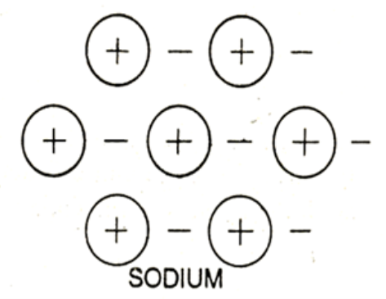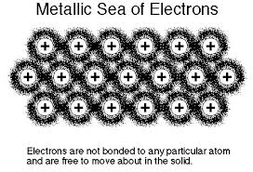

**Hydrogen bonds:-**

When hydrogen atom is covalently bonded to a strongly electronegative and small-sized atom (N2, O2 & F), results in the development of partial ionic character in the covalent bond, with a fractional + ve charge in the hydrogen atom, and a fractional – ve charge on the fluorine atom.

For Eq:- HF

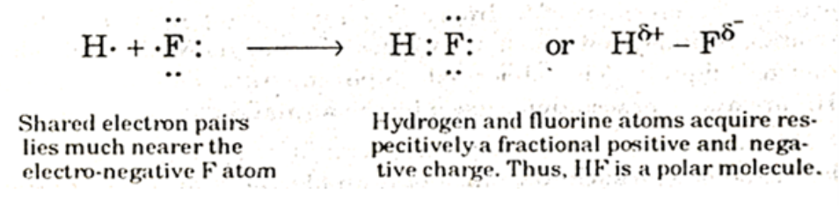

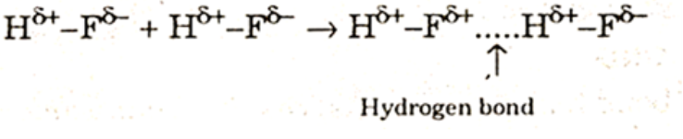

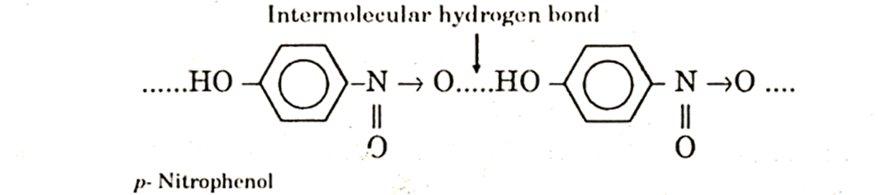INTERMOLECULAR HYDROGEN BOND

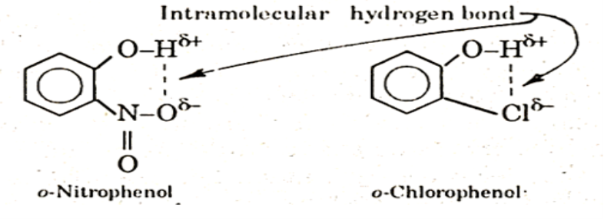

**Dipole-Dipole bonds:-**

HCl is an example of polar molecule. The positive end of one dipole attracts the negative end of the other. There is a net attraction between the polar molecules.

**Dipole-Induced dipole bonds:-**

Polar molecules will induce a dipole in adjacent non-polar molecules, and a bond will form as a result of attractive forces between the dipole and induced dipole.

Example:- Ionic solid is dissolved in solvent.

**Induced Dipole- Induced Dipole Interaction:- (London Forces or Dispersive Forces)**

* As we know, vander Waals forces exist even in non-polar molecules such as O2 and N2 and also in non-polar monoatomic molecules such as He, Ne, Ar, etc. This attraction is evident from the condensation of these gases into liquids at sufficiently high pressures and low temperatures.

**“This concept is explained by London”**

* According to this view, electrons of a neutral molecule keep on oscillating

with respect to the nuclei of the atoms. As a result of this, at a given

instant, positive charge may be concentrated in one region and negative

charge in another region of the same molecule.

* This polarized molecule induced the dipolemoment in a neighbouring molecule with antiparallel orientation.
* The electrostatic forces of attraction between induced dipoles and the original dipoles (due to electron oscillation) are known as London forces.
* These forces are also called dispersive forces because dispersion of light is also connected with these dipoles.

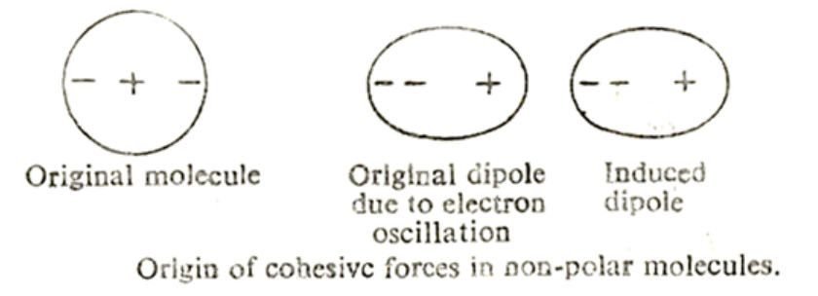

**DISPERSION  
(London) FORCES among non polar molecules**

**- It is caused by momentary oscillations of electron charge in atoms**

